Choose **only one** of the following Challenges and solve it.

**Challenge A: Board Image Reconstruction**

1. Write a program that stitches the images from the archive to obtain a full board as in the image. <https://drive.google.com/file/d/1RFrw1gsZwIhLAfx92i3bPCq9HCNZHPRC/view?usp=sharing>

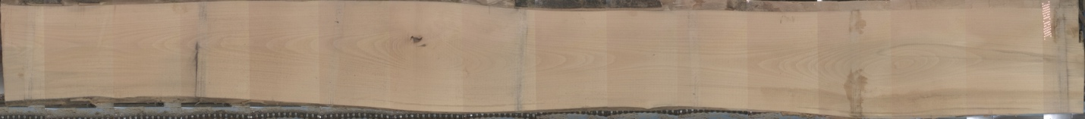

1. 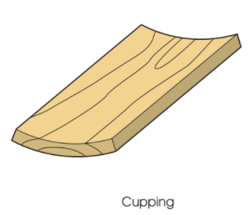The images in the following archive are of a board that has *cup shape*. Can you think of a method for determining if the board is cupped only from the available images?

<https://drive.google.com/file/d/11tlBay-GPQkxdwpXsWEDBA5REWAdmtss/view?usp=sharing>

**Challenge B: Wood Species Classification**

1. Train a model that classifies between the Red Oak, Soft Maple, and Hard Maple on this dataset.

<https://drive.google.com/file/d/1k95Re78RCYgehjzr1ogBydI7iAMB2y7j/view?usp=drive_link>

1. Evaluate your model on the test set.
2. Study the failure cases of the model.